
INTERNATIONAL CYBERSECURITY AND DIGITAL FORENSICS ACADEMY

ASSIGNMENT

Assignment Title: PC Systems Fundamentals, Disk Sectors and Partition Analysis
Student Name: Ahmad Zubairu Garba
Student ID: 2025/FWSD/11463
Course Title: Basic Computer Skills for Digital Forensics
Course Code: SBT-DF201
Instructor: Aminu Idris

August 09, 2026
INTRODUCTION
This comprehensive digital forensics laboratory exercise is meticulously designed to establish a profound, foundational understanding of computer architecture by systematically exploring core investigative domains, including system identification, multi-layered evidence mapping, real-time process observation, and detailed disk structure enumeration.
Students and investigators learn how to safely, methodically, and legally inspect target operational systems without altering, contaminating, or compromising volatile or persistent digital evidence.
By leveraging specialized read-only utilities, forensic examiners bridge the gap between theoretical system architecture and practical field triage across both Microsoft Windows and Linux-based operational ecosystems.
Analyzing underlying partition tables, tracking exact drive capacities, dissecting boot mechanisms, and auditing running process trees equips practitioners with essential technical acumen.
These core competencies form the vital structural baseline required to execute advanced digital investigations, incident response protocols, and complex malware analysis workflows effectively.

Tools and Environments Used
  - Operating Systems:
    - Microsoft Windows 11 Home serves as the primary proprietary desktop environment for examining standard user configurations, registry structures, and native GUI-based administrative tools.
    - Kali Linux acts as the dedicated open-source forensic and penetration testing platform utilized for low-level disk analysis, command-line triage, and advanced packet evaluation.
  - Windows Utilities & Commands:
    - System Information (msinfo32) provides a comprehensive hardware, system components, and software environment overview.
    - Windows Task Manager enables real-time observation of active applications, running processes, performance metrics, and resource utilization.
    - PowerShell cmdlets specifically Get-Disk, Get-Partition, and Get-Volume—facilitate precise, scriptable storage enumeration alongside tasklist for process auditing.
    - Disk Management (diskmgmt.msc) offers a graphical partition mapping interface, while the Command Prompt utility diskpart delivers deep, text-based disk partitioning and volume management controls.
  - Linux Utilities & Commands:
    - lsblk lists block devices in a clean, hierarchical tree format to visualize drive layouts and mount points.
    - fdisk and parted are employed for inspecting, analyzing, and manipulating partition tables across various disk label formats.
    - blkid locates and prints block device attributes, including UUIDs and filesystem types, for precise evidence mapping.
    - df reports file system disk space usage to track available capacity and volume saturation during triage.

Part A - System Identification and Evidence Layer Mapping
To establish a foundational profile of the target system, system specifications and storage properties were captured via safe, read-only utilities, and evidence sources were mapped across computer system layers.
The system hardware and configuration details extracted from System Information include:
- OS Name & Version: Microsoft Windows 11 Home, Version 10.0.26200 Build 26200.
- System Type: x64-based PC powered by an AMD Ryzen 5 7520U with Radeon Graphics.
- BIOS Mode & Security: UEFI firmware with Secure Boot configured to Off.
- Physical Memory: Installed physical memory and system layout details as documented from the host diagnostics.
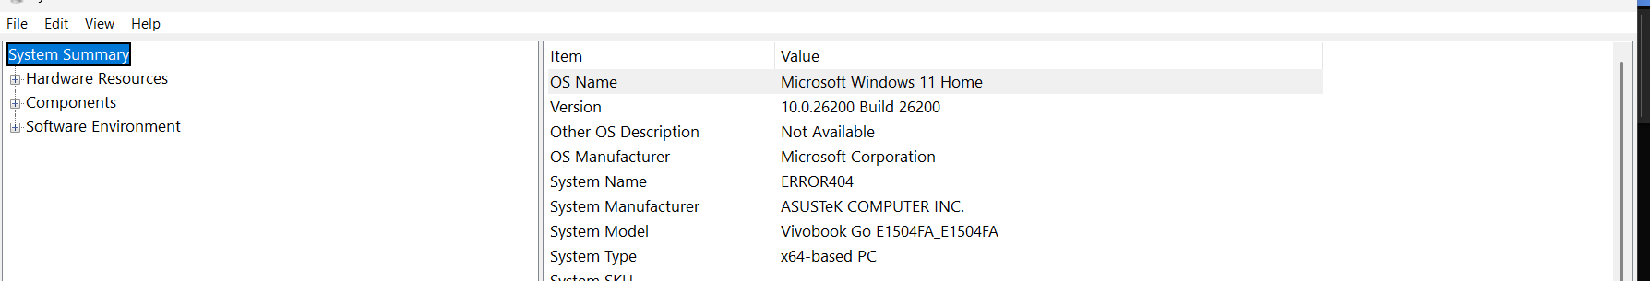
(System Information window displaying OS Name, Version, System Model, Processor, BIOS Mode, and Secure Boot State)

To examine storage configuration safely without modifying persistent data, read-only PowerShell inspection commands were executed, revealing the multi-partition layout and file system metrics:
- Physical Disk & Model: The storage configuration runs on the host NVMe hardware with healthy operational status.
- Partition Architecture: The partition table contains multiple segments including the EFI system partition, reserved spaces, recovery volumes, and the primary OS partition.
- File System Type: Volume inspection confirms the primary drives utilize the NTFS file system, providing necessary transactional logging and metadata support for forensic investigation.
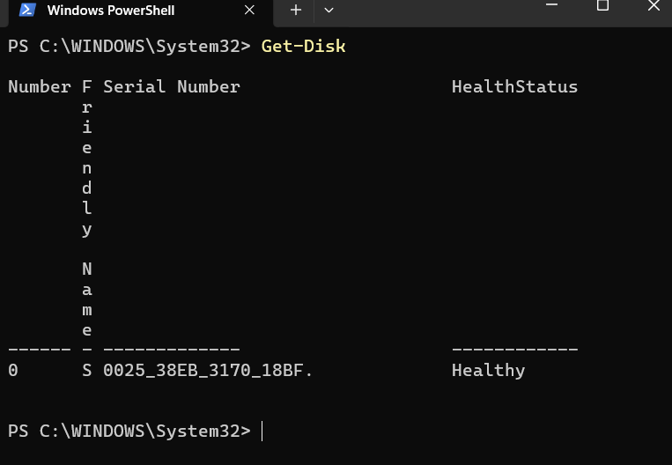
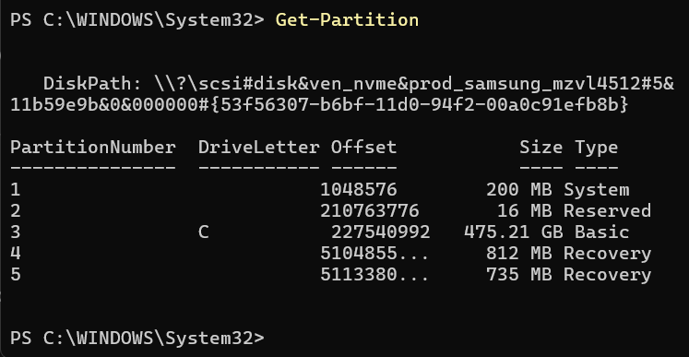
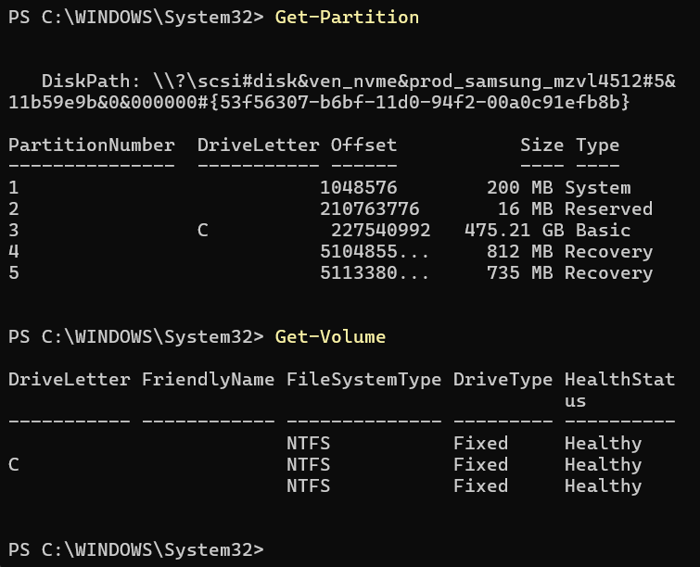
To understand how digital artifacts are generated and preserved, system operations are mapped across five core layers:
Layer / Source | Example Evidence | Where It May Be Found | Why It Matters
User layer | Typed keyboard input, desktop wallpaper changes, or window focus history | User Assist registry keys, ShellBags, or Recent Items folders | Directly associates specific human actions with interface interactions.
Application layer | Browser download history, locally saved chat transcripts, or email attachments | Application-specific SQLite databases, local cache folders (%AppData%) | Details the specific software tools utilized to manipulate or transmit data.
OS layer | Service start/stop times, driver installation records, or power state transitions | System Event Logs (.evtx), Windows Registry (SYSTEM hive) | Provides the system-wide timeline of administrative and background operations.
Disk layer | File slack space, Volume Shadow Copies (VSC), or hidden partition data | Raw physical sectors, Master File Table ($MFT$), or unallocated clusters | Facilitates recovery of deleted data and low-level forensic reconstruction.
Memory/process layer | Decrypted passwords in cleartext, active network socket states, or injected malicious DLLs | Pagefile.sys, hiberfil.sys, or captured volatile RAM dumps | Captures state-dependent artifacts that vanish upon system power-off.

Evidence frequently exists in more than one layer because user activity propagates across the entire architecture ($\text{User Activities}=\text{Applications}+\text{Operating System}+\text{Disk/Memory}$). For instance, initiating an action starts at the user interface, triggers application processing, generates operating system kernel and event logs, leaves persistent entries on the disk file system, and maintains temporary states in volatile memory. Correlating these artifacts across layers allows investigators to build reliable, verifiable timelines.

Part B - Process Observation and Management
To observe running system processes and understand system activity from both command-line and graphical interfaces, live process enumeration commands (tasklist) and Windows Task Manager were utilized.
Process enumeration was conducted via PowerShell to output active processes, Process IDs (PIDs), session names, and memory utilization metrics.
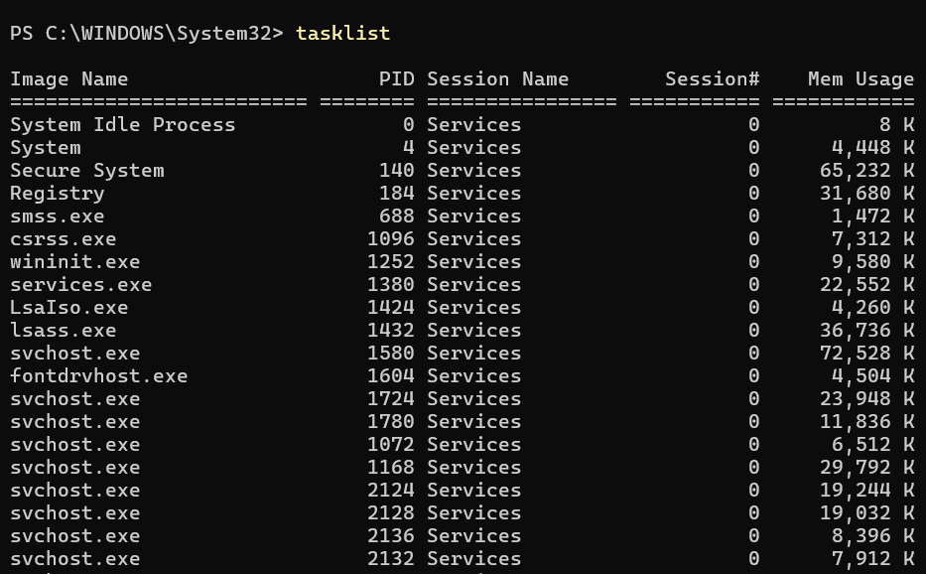
Simultaneously, the graphical interface view was captured using Task Manager to display active applications and background services categorized with resource consumption.
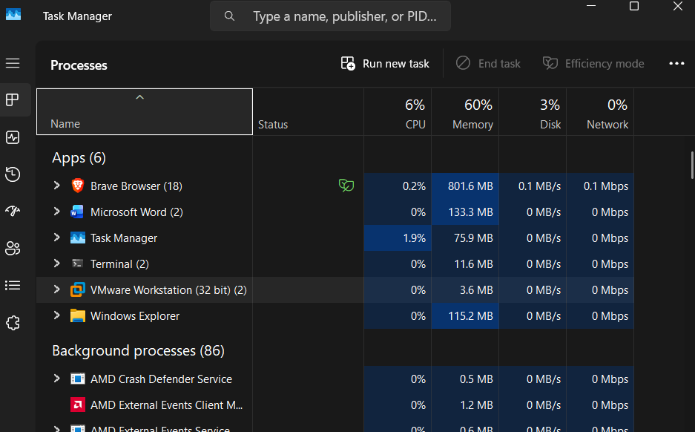
Based on the process captures, several foundational Windows processes maintain system stability and operation:
- System Idle Process (PID 0): Represents the percentage of unused CPU capacity. High memory usage is negligible here, as its primary metric tracks processor downtime.
- smss.exe (Session Manager Subsystem): Responsible for initializing the user session, creating environment variables, and starting subsystems like csrss.exe.
- csrss.exe (Client/Server Runtime Subsystem): Manages graphical instruction sets, console windows, and thread creation.
- wininit.exe (Windows Initialization Process): Starts core background services, the Local Security Authority Process (lsass.exe), and the Service Control Manager (services.exe).
- services.exe: Manages the starting, stopping, and interaction of background Windows services.
- lsass.exe (Local Security Authority Subsystem Service): Enforces security policies, handles user logins, and manages password changes and access tokens.
- svchost.exe (Service Host): A generic host process container used to run multiple Windows services from DLL files, reducing resource overhead.
Difference between Program vs. Process vs. Thread
A program is just a static file sitting on your hard drive, a process is that program actually running in memory with its own resources, and a thread is the smaller path of execution inside that process doing the actual work.
Importance in Malware Analysis and Live Forensic Triage
Process information is useful during live triage because it instantly reveals active malicious activity, hidden injections, or running payloads that would otherwise remain invisible while sitting dormant on the disk.
Part C – Disk Sector and Disk Size Calculation
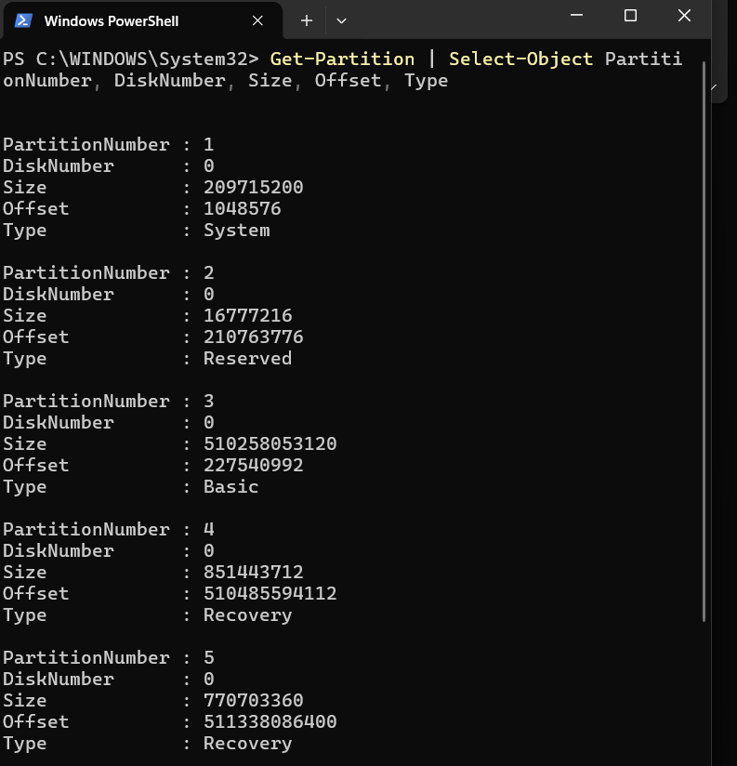
(PowerShell output of Get-Partition showing Partition 1 size of 209715200 bytes and Partition 3 size of 510258053120 bytes)
C2. Calculate Your Own Partition Size
Using the partition size values in bytes extracted directly from your PowerShell output, here are the step-by-step calculations for Partition 1 and Partition 3 following the required format:
Partition 1 (System Partition — Size: 209,715,200 bytes)
Item | Formula / Value | Answer
Total bytes | Given partition size in bytes | $$209,715,200\text{ bytes}$$
Kilobytes | $$209,715,200/1024$$ | $$204,800\text{ KB}$$
Megabytes | $$204,800/1024$$ | $$200\text{ MB}$$
Gigabytes | $$200/1024$$ | $$0.1953\text{ GB}$$
Partition 3 (Basic OS Partition — Size: 510,258,053,120 bytes)
Item | Formula / Value | Answer
Total bytes | Given partition size in bytes | $$510,258,053,120\text{ bytes}$$
Kilobytes | $$510,258,053,120/1024$$ | $$498,298,880\text{ KB}$$
Megabytes | $$498,298,880/1024$$ | $$486,620\text{ MB}$$
Gigabytes | $$486,620/1024$$ | $$475.21\text{ GB}$$

Part D – Safe Partition Table Inspection
Windows Method: Disk Management, PowerShell, and DiskPart Inspection
This section documents the safe, read-only inspection of the Windows partition table and disk layout using native Windows utilities (diskmgmt.msc, PowerShell, and DiskPart) without modifying the underlying disk.
Step 1: Disk Management Layout
- Pressed Windows + R, typed diskmgmt.msc, and pressed Enter to open Disk Management.
- Verified the disk layout, volume structure, file systems, and partition health status. Disk 0 is initialized as a GPT (GUID Partition Table) disk with a total capacity of 476.92 GB containing an EFI System Partition, the main OS volume (C:), a Microsoft Reserved partition, and recovery partitions.
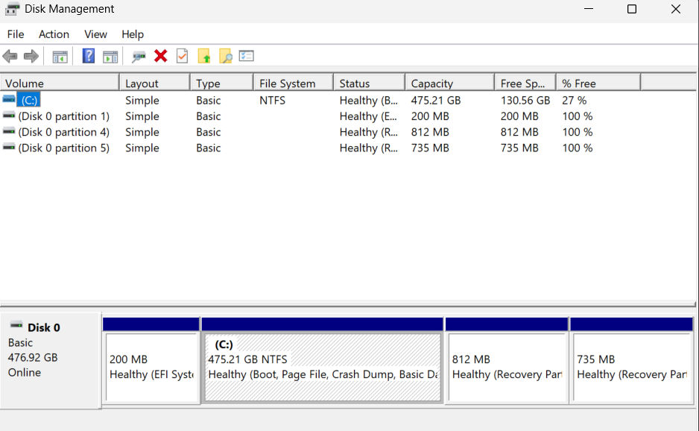
Step 2: DiskPart Safe Listing Commands
- Opened Command Prompt as an administrator and launched the interactive utility via diskpart.
- Executed safe, read-only listing commands (list disk, select disk 0, list partition) to verify the partition types and offsets.
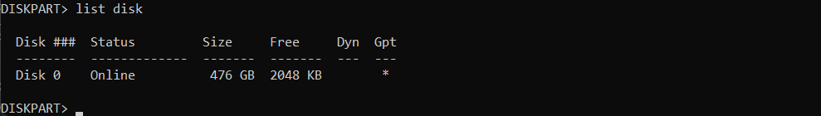
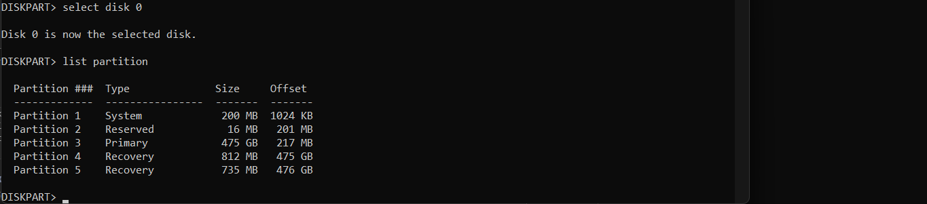
D2. Linux / Kali Method: Read-Only Partition Table Inspection
This section documents the safe, read-only inspection of disk layouts, block devices, partition tables, and mount points inside a Linux/Kali environment using standard diagnostic tools without writing changes (mkfs, fdisk writes, parted writes, or dd).
Step 1: Block Device Layout (lsblk)
- Ran lsblk -o NAME,SIZE,TYPE,FSTYPE,MOUNTPOINT to view the hierarchical relationship of block devices and their file systems.

Step 2: Partition Table Inspection (fdisk & parted)
- Executed sudo fdisk -l to inspect the disk label type, sector sizes, and raw partition entry data.
- Executed sudo parted -l to view logical and physical sector configurations alongside partition table types (such as msdos or mac).
Step 3: File System Attributes & Disk Space (blkid & df)
- Ran blkid to retrieve universally unique identifiers (UUIDs) and block device attributes safely in read-only mode.
- Ran df -h to examine mounted file system disk space utilization in human-readable formats.
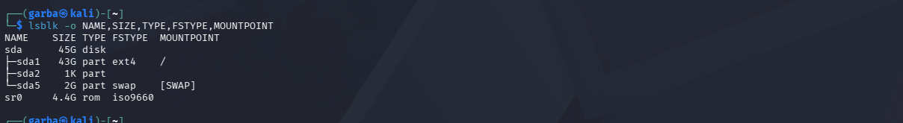
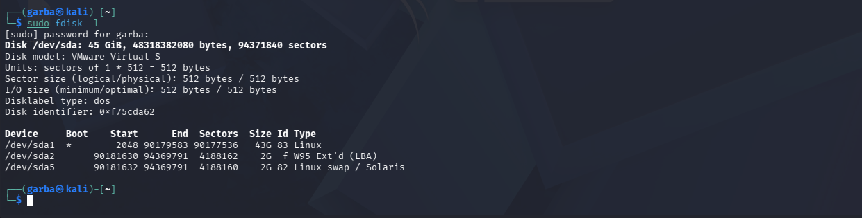
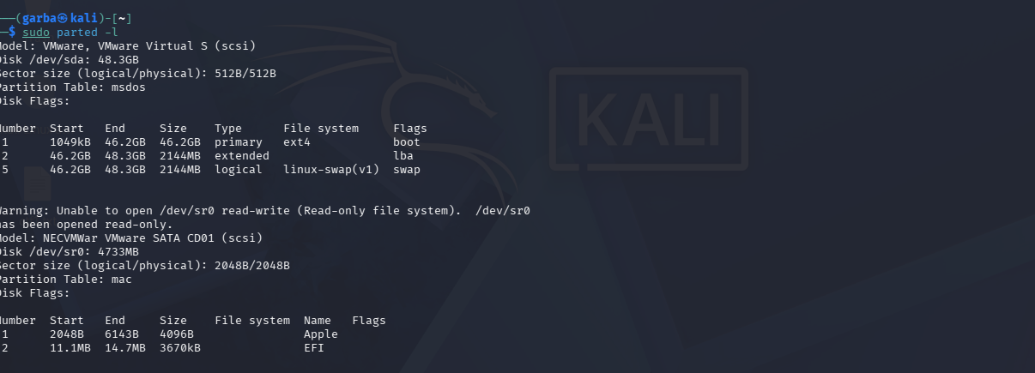
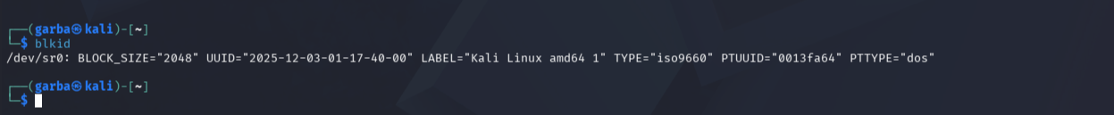
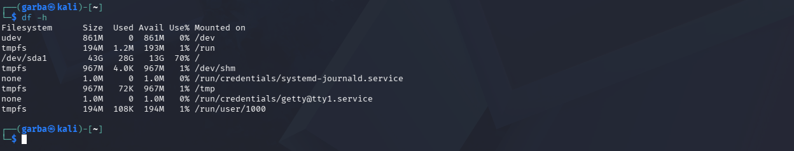
Part E - MBR, GPT, and Boot Process Explanation
E1. System Boot Process Breakdown
When a computer starts up, it follows a structured initialization sequence before handing control over to the user. Each phase plays a vital role during digital investigations:
Stage | What Happens | Forensic Relevance
Power-on and POST | The machine draws power, and the Power-On Self-Test verifies core components like RAM, CPU, and storage. | Hardware-level tampering or physical faults can hinder data extraction or evidence collection.
BIOS/UEFI firmware | The motherboard firmware runs, checking non-volatile memory for configuration settings and boot priority orders. | Identifying whether a machine booted via Legacy BIOS or UEFI explains the disk partition structure and boot artifacts found later.
MBR/GPT or EFI boot | The firmware scans the storage drive to locate the primary boot records or EFI system partition files. | Boot records retain configuration artifacts that can reveal unauthorized modifications or alternative boot configurations.
Boot loader/manager | Software like Windows Boot Manager or GRUB loads into memory to initialize OS files or offer a multi-boot menu. | Examining this stage can uncover hidden operating systems, dual-boot setups, or customized boot payloads.
Kernel and OS control | The core operating system kernel takes over, launching system drivers, services, and user authentication. | This is where persistent system logs, event histories, and user activity artifacts begin accumulating on the disk.
Firmware Identification for This System
Based on evidence gathered during our disk inspections (such as the presence of an EFI system partition and GPT formatting in Disk Management), this system utilizes modern UEFI firmware rather than a legacy BIOS setup.
E2. Structural Comparison: MBR vs. GPT
Feature | MBR (Master Boot Record) | GPT (GUID Partition Table)
Design Origin | Developed in the early 1980s alongside legacy BIOS architectures. | A modern partitioning standard introduced to replace MBR alongside UEFI.
Capacity Limit | Strictly restricted to handling drives up to roughly 2 TB in size. | Massively scalable, supporting storage capacities up to approximately 9.4 ZB.
Table Storage | Stores partition data and boot code directly inside the very first sector of the drive. | Distributes structural data using primary and secondary (backup) headers across the disk.
Forensic Challenges | Because vital details sit entirely in sector 0, minor corruption can cause total partition loss. | Features built-in redundancy via backup structures, making validation and recovery significantly safer.
Part F - Logical Disk and Volume Enumeration (Linux / Kali Environment)
Executed Commands and Utility Overview
To inspect mounted file systems, block storage hierarchies, and disk utilization safely in read-only mode, the following commands were run:
- lsblk -f: Lists block devices alongside their allocated file systems (ext4, swap, iso9660), version labels, UUIDs, and mount points.
- blkid: Displays low-level block device attributes and universally unique identifiers.
- df -Th: Provides a human-readable summary of mounted file systems, types (such as ext4 and tmpfs), total sizes, used space, and usage percentages.

F2. Terminal Evidence & Output Captures
- Block Device File System Mapping (lsblk -f):
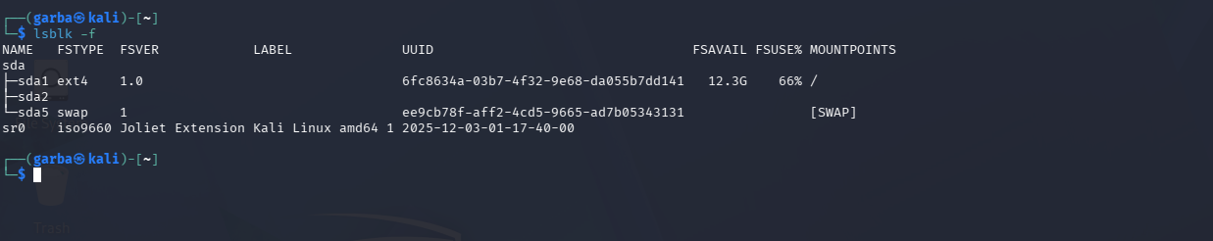
- Block Device Attribute Identification (blkid):
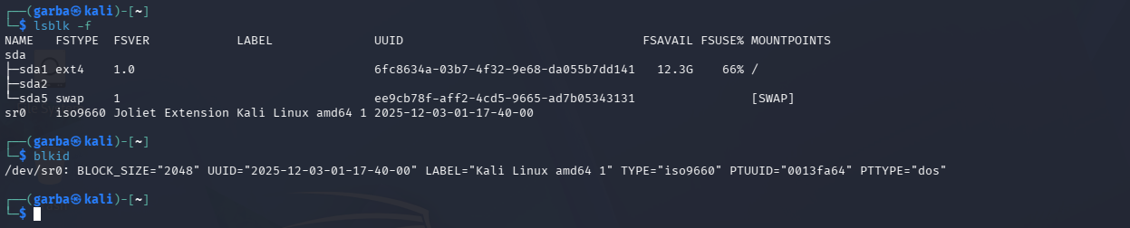
- File System Disk Space Utilization (df -Th):
